ADM01-AI LAB

Experiment 5: Solving the 8-Queens Problem Using Backtracking
AIM: To find the collision-free placement of components on a grid.
QUESTION:
An automated placement system must position eight components on an 8 × 8 grid such that no two components interfere with one another. Model this as the 8-Queens problem, where each queen represents a component and can attack another queen along the same row, column, or diagonal.
Develop a Python program using the backtracking algorithm to find a valid arrangement of eight queens on the chessboard.
The program must:
- Represent the chessboard as an 8 × 8 grid and track the positions of the queens.
- Place one queen at a time while ensuring that no two queens share the same row, column, or diagonal.
- Use recursive backtracking to undo an invalid placement and explore alternative positions.
- Display the final chessboard arrangement and the positions of all eight queens.
- Report the number of placement attempts and explain how constraint checking and backtracking help find a valid solution.

CODE
N = 8
board = [-1] * N
attempts = 0

def is_safe(row, col):
for prev_row in range(row):
prev_col = board[prev_row]

if prev_col == col:
return False

if abs(prev_col - col) == abs(prev_row - row):
return False

return True

def solve(row):
global attempts

if row == N:
return True

for col in range(N):
attempts += 1

if is_safe(row, col):
board[row] = col

if solve(row + 1):
return True

board[row] = -1

return False

if solve(0):
print("Valid 8-Queens Solution:\n")

for row in range(N):
for col in range(N):
if board[row] == col:
print("Q", end=" ")
else:
print(".", end=" ")
print()

print("\nQueen Positions (Row, Column):")
for row in range(N):
print(f"Queen {row + 1}: ({row + 1}, {board[row] + 1})")

print("\nTotal Placement Attempts:", attempts)
else:
print("No solution found.")

OUTPUT
Valid 8-Queens Solution:

Q . . . . . . .
. . . . Q . . .
. . . . . . . Q
. . . . . Q . .
. . Q . . . . .
. . . . . . Q .
. Q . . . . . .
. . . Q . . . .

Queen Positions (Row, Column):
Queen 1: (1, 1)
Queen 2: (2, 5)
Queen 3: (3, 8)
Queen 4: (4, 6)
Queen 5: (5, 3)
Queen 6: (6, 7)
Queen 7: (7, 2)
Queen 8: (8, 4)

Total Placement Attempts: 876

Experiment 6: Solving the Map Colouring Problem Using CSP
AIM: To make frequency allocation for neighbouring cellular network regions.
QUESTION:
A telecommunications network is divided into interconnected regions. To reduce interference, neighbouring regions must be assigned different frequency bands. Model the network as a Constraint Satisfaction Problem (CSP), where each region is a variable, the available frequency bands form its domain, and neighbouring regions must receive different assignments.
Develop a Python program to solve the map-colouring problem using CSP techniques.
The program must:
- Represent each region as a variable and define its available colours as a domain.
- Specify adjacency constraints requiring neighbouring regions to have different colours.
- Use backtracking search to find a valid colour assignment.
- Display the final map-colouring assignment and verify that all adjacency constraints are satisfied.
- Report the number of assignments attempted and explain how CSP variables, domains, and constraints guide the search.
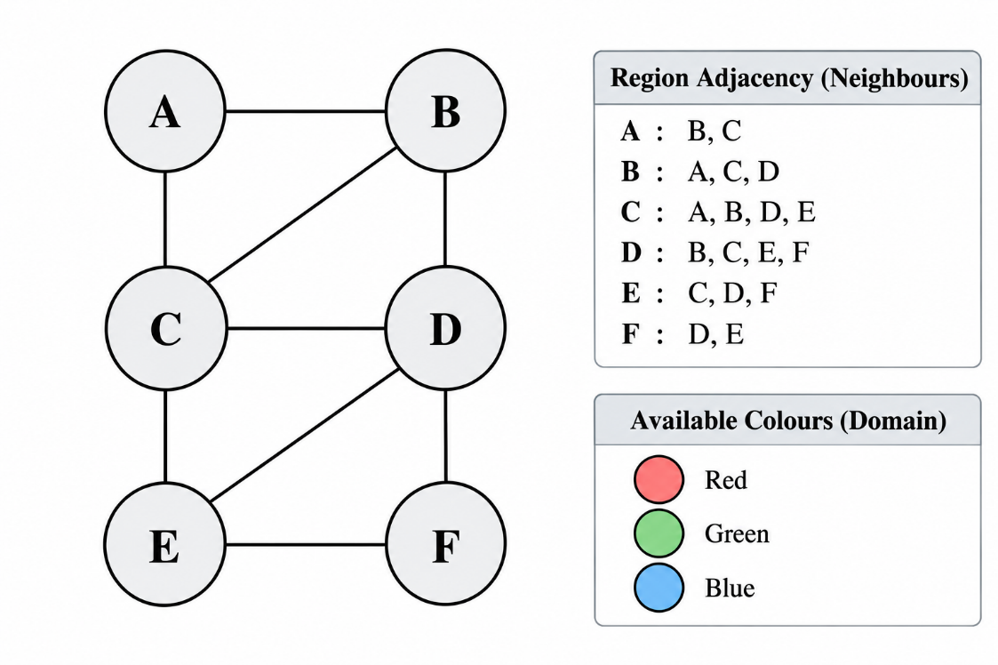
CODE
regions = ['A', 'B', 'C', 'D', 'E', 'F']

domains = ['Red', 'Green', 'Blue']

neighbours = {
'A': ['B', 'C'],
'B': ['A', 'C', 'D'],
'C': ['A', 'B', 'D', 'E'],
'D': ['B', 'C', 'E', 'F'],
'E': ['C', 'D', 'F'],
'F': ['D', 'E']
}

assignment = {}
attempts = 0

def is_safe(region, colour):
for neighbour in neighbours[region]:
if assignment.get(neighbour) == colour:
return False
return True

def solve(index):
global attempts

if index == len(regions):
return True

region = regions[index]

for colour in domains:
attempts += 1

if is_safe(region, colour):
assignment[region] = colour

if solve(index + 1):
return True

del assignment[region]

return False

if solve(0):
print("Map Colouring Solution:\n")

for region in regions:
print(region, ":", assignment[region])

valid = True
for region in regions:
for neighbour in neighbours[region]:
if assignment[region] == assignment[neighbour]:
valid = False

print("\nAll adjacency constraints satisfied:", valid)
print("Total Assignment Attempts:", attempts)
else:
print("No valid colouring exists.")

OUTPUT
Map Colouring Solution:

A : Red
B : Green
C : Blue
D : Red
E : Green
F : Blue

All adjacency constraints satisfied: True
Total Assignment Attempts: 12

Experiment 7- Implementing the Minimax Algorithm
AIM: To demonstratedecision-making in a two-player strategy game.
QUESTION:
A game-playing AI must select its best move in a two-player game where one player tries to maximize the score while the opponent tries to minimize it.
Develop a Python program to implement the Minimax algorithm for a game represented as a binary game tree. The program must:
- Represent the game tree with terminal utility values.
- Treat the AI as the maximizing player and the opponent as the minimizing player.
- Recursively evaluate the game tree using the Minimax algorithm.
- Display the evaluated values and the best move selected by the AI.
- Explain how the algorithm assumes that both players choose optimal moves.

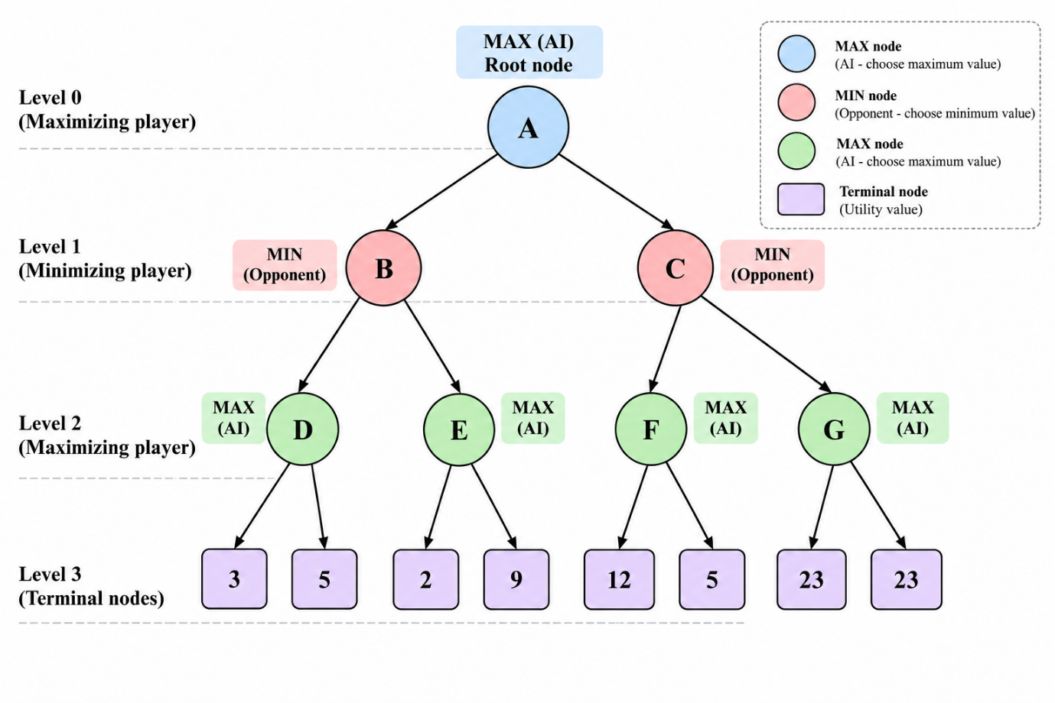

CODE
# Minimax Algorithm

tree = {
'A': ['B', 'C'],
'B': ['D', 'E'],
'C': ['F', 'G'],
'D': [3, 5],
'E': [2, 9],
'F': [12, 5],
'G': [23, 23]
}

def minimax(node, maximizing):
if isinstance(tree[node][0], int):
return max(tree[node]) if maximizing else min(tree[node])

values = []
for child in tree[node]:
values.append(minimax(child, not maximizing))

if maximizing:
return max(values)
else:
return min(values)

# Evaluate the game tree
print("Minimax Values:")

for node in ['D', 'E', 'F', 'G']:
print(node, "=", max(tree[node]))

B_value = min(max(tree['D']), max(tree['E']))
C_value = min(max(tree['F']), max(tree['G']))
A_value = max(B_value, C_value)

print("B =", B_value)
print("C =", C_value)
print("A =", A_value)

if B_value > C_value:
print("Best Move for AI: B")
else:
print("Best Move for AI: C")

print("Best Utility Value:", A_value)

OUTPUT
Minimax Values:
D = 5
E = 9
F = 12
G = 23
B = 5
C = 12
A = 12
Best Move for AI: C
Best Utility Value: 12

Experiment 8- Implementing Alpha-Beta Pruning
AIM: Tooptimize decision-making in a two-player strategy game.
QUESTION:
A chess-playing AI evaluates possible moves by exploring a game tree. Since evaluating every possible move is computationally expensive, the AI uses Alpha-Beta Pruning to eliminate branches that cannot influence the final decision.
Develop a Python program to implement the Alpha-Beta Pruning algorithm for a chess-inspired game tree with multiple possible moves and terminal utility values.
The program must:
- Represent the game tree with multiple candidate moves and terminal utility values.
- Implement Alpha-Beta Pruning using alpha and beta bounds.
- Identify and skip branches that cannot affect the final decision.
- Display the selected move, its utility value, the number of nodes evaluated, and the number of branches pruned.
- Explain how Alpha-Beta Pruning reduces the search effort while preserving the optimal decision.

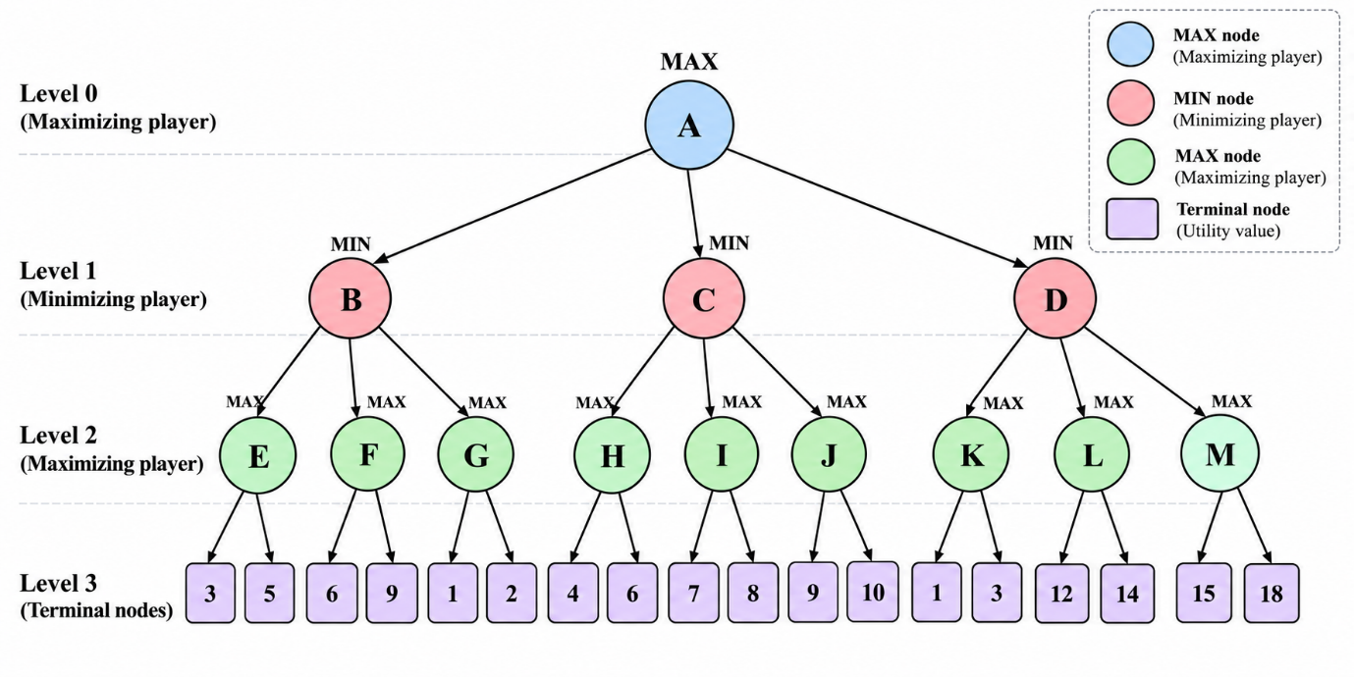

CODE
# Alpha-Beta Pruning Algorithm

tree = {
'A': ['B', 'C', 'D'],
'B': ['E', 'F', 'G'],
'C': ['H', 'I', 'J'],
'D': ['K', 'L', 'M'],
'E': [3, 5],
'F': [6, 9],
'G': [1, 2],
'H': [4, 6],
'I': [7, 8],
'J': [9, 10],
'K': [1, 3],
'L': [12, 14],
'M': [15, 18]
}

evaluated = 0
pruned = 0

def alpha_beta(node, maximizing, alpha, beta):
global evaluated, pruned

if isinstance(tree[node][0], int):
values = tree[node]
best = max(values) if maximizing else min(values)
evaluated += len(values)
return best

if maximizing:
value = float('-inf')

for child in tree[node]:
value = max(value, alpha_beta(child, False, alpha, beta))
alpha = max(alpha, value)

if alpha >= beta:
pruned += 1
break

return value

else:
value = float('inf')

for child in tree[node]:
value = min(value, alpha_beta(child, True, alpha, beta))
beta = min(beta, value)

if alpha >= beta:
pruned += 1
break

return value

best_value = float('-inf')
best_move = None
alpha = float('-inf')
beta = float('inf')

for child in tree['A']:
value = alpha_beta(child, False, alpha, beta)

if value > best_value:
best_value = value
best_move = child

alpha = max(alpha, best_value)

print("Best Move:", best_move)
print("Best Utility Value:", best_value)
print("Terminal Nodes Evaluated:", evaluated)
print("Pruning Events:", pruned)

OUTPUT
Best Move: C
Best Utility Value: 6
Terminal Nodes Evaluated: 14
Pruning Events: 1

